

**Movie Recommendation System Based On Emotions using Deep Learning**

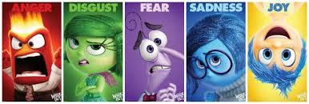

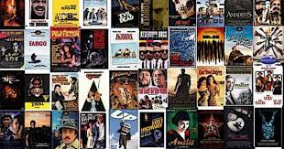

**Team Members**

T. S. L. V. S. Nikhitha (20481A5458) (Team Lead)

A. Sruthi (20481A5405)

T. Karthik (20481A5456)

D. Soma Venkat (20481A5413)

**Table of Contents**

|  |  |  |  |  |  |
| --- | --- | --- | --- | --- | --- |
|  | | | | **Topic** | **Page No.** |
| **1** | | | Introduction | | **1** |
|  | **1.1** | | | Overview | **1** |
|  | **1.2** | | | Purpose | **2** |
| **2** | | | Literature Survey | | **3** |
|  | **2.1** | | | Existing problem | **3** |
|  | **2.2** | | | Proposed solution | **4** |
| **3** | | | Theoritical Analysis | | **5** |
|  | **3.1** | | | Block diagram | **5** |
|  | **3.2** | | | Software designing | **6** |
| **4** | | | Experimental Investigations | | **7** |
| **5** | | | Flowchart | | **8** |
| **6** | | | Result | | **9** |
| **7** | | | Advantages & Disadvantages | | **10** |
| **8** | | | Applications | | **10** |
| **9** | | | Conclusion | | **10** |
| **10** | | | Future Scope | | **10** |
| **11** | | | Biblography | | **11** |
|  | | **11.1** | | Source Code | **12** |

1. **INTRODUCTION**
2. **Overview: -**

The "Movie Recommendation Based on Emotions" project is an innovative and revolutionary endeavor that aims to revolutionize the movie-watching experience. Unlike conventional movie recommendation systems, this project takes a distinctive approach by incorporating emotions as a pivotal aspect in suggesting movies to users. Emotions play a significant role in shaping our preferences and reactions to cinematic content, making it a powerful factor to consider for personalized movie suggestions.

At the heart of this project lies an advanced and intelligent web application that utilizes emotional recognition technology. Users are presented with a user-friendly interface where they can select their current emotional state from a diverse range of options, including happiness, sadness, anger, disgust, or thoughtfulness. The application's cutting-edge technology then accurately identifies and comprehends the user's emotional disposition, enabling it to delve deeper into the vast world of movies to recommend films that align with the selected emotion.

Through a meticulous and data-driven approach, the project scours extensive databases of movies to match each user's emotional context with a tailored list of recommendations. By presenting movies that resonate with the user's feelings, the project seeks to elevate the movie-watching experience to new heights of satisfaction and emotional resonance. Each movie recommendation is carefully curated to create an emotional connection between the viewer and the cinematic narrative, fostering a profound sense of engagement and immersion.

The user interface is designed to be intuitive and aesthetically pleasing, providing a seamless experience for users to navigate and select their emotions effortlessly. The application's ability to recognize and adapt to individual emotions enhances its appeal and usability, making it an ideal platform for diverse audiences seeking meaningful and impactful movie experiences.

Movie Recommendation Based on Emotions project represents a significant leap in movie recommendation technology. By leveraging emotional recognition and personalization, it aspires to create a profound and emotionally resonant cinematic journey for every user. Through its innovative approach, the project seeks to redefine how people engage with movies, fostering a deeper appreciation for the art of storytelling through the lens of their unique emotional states.

**1.2 Purpose**: -

The primary purpose of the "Movie Recommendation Based on Emotions" project is to bridge the gap between human emotions and movie content. By accurately recognizing and comprehending the user's emotional state, the system aspires to curate a bespoke list of movie recommendations that resonate deeply with the individual's feelings. This personalization elevates the movie-watching experience from a mere pastime to a profound journey of emotional connection, allowing users to immerse themselves fully in the world of cinema that mirrors their innermost emotions.

Through this project, users will have the opportunity to explore a diverse range of movies, each carefully chosen to evoke emotions that align with their current state of mind. Whether seeking solace in heartwarming tales during moments of sadness or finding empowerment in thrilling adventures during times of anger, this application endeavors to offer a cinematic journey that speaks directly to the heart of the viewer.

Moreover, the project aims to foster a stronger connection between users and the world of cinema by introducing them to movies they might have otherwise overlooked. By breaking away from traditional recommendation algorithms, which often lead to repetitive suggestions, this project opens the doors to an uncharted cinematic landscape where users can discover hidden gems that resonate with their emotional needs.

In essence, the "Movie Recommendation Based on Emotions" project serves as a bridge between the vast realm of movies and the intricate realm of human emotions, transforming movie-watching into an intimate and captivating experience that transcends mere entertainment.

With a foundation built on the innovative intersection of technology and emotions, this project aspires to redefine how people engage with movies, fostering a more profound appreciation for the art of storytelling through the lens of their unique emotional lens.

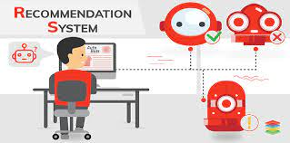

1. **LITERATURE SURVEY**

**2.1 Existing problem: -**

The realm of movie recommendation systems has witnessed significant advancements over the years, with various algorithms and approaches striving to provide users with tailored movie suggestions. However, traditional movie recommendation systems often grapple with an essential aspect that profoundly influences human preferences – emotions. The existing problem lies in the oversight of emotions as a critical factor in guiding movie choices, leading to suboptimal and generic recommendations that fail to resonate with users on an emotional level.

Emotions play a pivotal role in shaping our preferences and reactions to various stimuli, including movies. Human emotions can fluctuate throughout the day, influenced by personal experiences, social interactions, and the environment. The emotional state of an individual greatly impacts their receptivity to specific content, including movies. For instance, a person feeling joyful may seek lighthearted and uplifting movies, while someone feeling introspective may prefer thought-provoking and dramatic films. However, existing movie recommendation systems often overlook these emotional nuances, leading to recommendations that do not align with the user's current emotional needs.

Another challenge posed by the absence of emotional consideration is recommendation diversity. Users often seek movie recommendations that introduce them to diverse genres, styles, and cultures. However, existing systems tend to offer repetitive suggestions based on past preferences, leading to a limited exposure to new cinematic experiences. By integrating emotions into the recommendation process, the system can broaden the scope of movie suggestions and foster a more eclectic and enriching movie-watching experience for users.

The oversight of emotions as a critical dimension of human preferences leads to generic, repetitive, and less emotionally resonant movie suggestions. By addressing this problem and incorporating emotions into the recommendation process, the "Movie Recommendation Based on Emotions" project seeks to create a more profound and personalized movie-watching experience that aligns with the user's unique emotional state.

**2.2 Proposed solution: -**

To address the existing problem of the underrepresentation of emotions in movie recommendation systems, the "Movie Recommendation Based on Emotions" project introduces a comprehensive and innovative solution. The proposed solution revolves around incorporating emotions as a fundamental dimension in the movie recommendation process, thereby offering users personalized and emotionally resonant movie suggestions.

The core of the proposed solution lies in the integration of advanced emotional recognition technology within the recommendation system. When users access the web application, they are presented with a visually appealing and user-friendly interface that offers a diverse range of emotions to choose from, such as happiness, sadness, anger, disgust, or thoughtfulness. Users can effortlessly select their current emotional state, enabling the system to gain a deeper understanding of their emotional context.

The proposed solution's key strengths lie in its ability to address the cold-start problem and provide diverse movie recommendations. By considering the user's current emotional state, the system can offer relevant and meaningful suggestions, even for new users or recently released movies with limited historical data. This personalized approach ensures that each user is catered to based on their present emotional needs, regardless of their prior movie-watching history.

Additionally, incorporating emotions into the recommendation process enriches the diversity of movie suggestions. Users are exposed to a broader spectrum of cinematic experiences, transcending genre boundaries and encouraging exploration of different movie styles and cultures. This diversity not only fosters a deeper appreciation for the art of storytelling but also introduces users to a plethora of cinematic narratives that align with their emotions, creating a more immersive and fulfilling movie-watching experience.

Furthermore, the proposed solution promotes a stronger emotional connection between users and the recommended movies. By presenting movies that resonate with the user's feelings, the system elicits a profound sense of engagement, empathy, and emotional immersion. Each movie recommendation is carefully curated to reflect the user's unique emotional lens, fostering a deep emotional connection and leaving a lasting impact on their cinematic journey.

**3. THEORETICAL ANALYSIS**

**3.1 Block diagram: -**

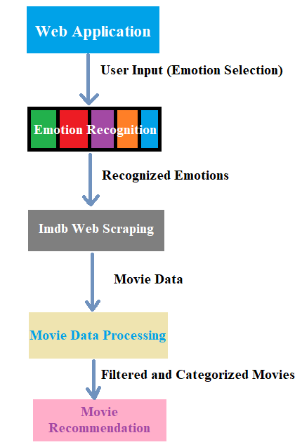

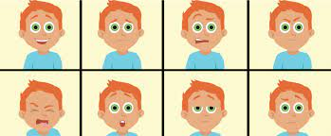

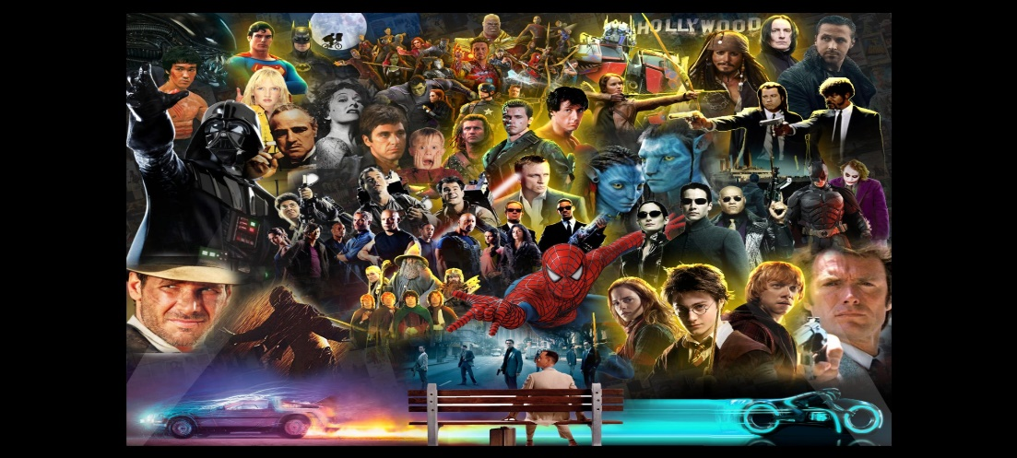

**3.2 Software designing: -**

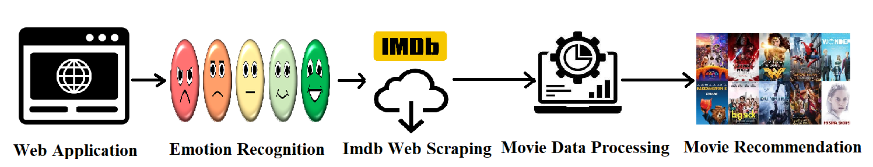

* ***Web Application: -***

The web application serves as the primary interface through which users interact with the movie recommendation system. It is developed using the Flask web framework, known for its simplicity and efficiency in building web applications. The web application provides a visually appealing and user-friendly interface, allowing users to select their current emotional state from a list of emotions, including happiness, sadness, anger, disgust, or thoughtfulness. The user's chosen emotion is then sent as input to the emotion recognition component.

* ***Emotion Recognition: -***

The emotion recognition component utilizes advanced artificial intelligence algorithms to accurately identify and comprehend the user's emotional state based on the input received from the web application. The emotion recognition process involves sophisticated machine learning models trained on vast emotional datasets, enabling the system to make accurate emotional predictions.

* ***IMDb Web Scraping: -***

To curate relevant movie recommendations based on the user's emotional state, the project relies on web scraping IMDb (Internet Movie Database). The IMDb web scraping component is responsible for retrieving movie data from IMDb's extensive database. It uses the popular BeautifulSoup library to parse the HTML content of IMDb web pages and extract essential movie details, including movie names, genres, ratings, directors, and actors. The scraped movie data is then sent to the movie data processing component for further analysis.

* ***Movie Data Processing: -***

The movie data processing component receives the scraped movie data and performs data preprocessing tasks to filter and categorize the movies based on their emotional relevance. It employs algorithms to match each movie's attributes with the user's selected emotion, thus creating a curated list of movie recommendations that evoke emotions in line with the user's emotional state.

* ***Movie Recommendation: -***

The final component, the movie recommendation module, is responsible for presenting the user with the personalized movie recommendations. It receives the curated list of emotionally relevant movies from the movie data processing component and displays them in the web application's interface. Each movie recommendation is accompanied by relevant details such as the movie name and a link to its IMDb page. Users can explore the recommended movies and access their IMDb pages to gain further insights into each film.

1. **EXPERIMENTAL INVESTIGATIONS**



The "Movie Recommendation Based on Emotions" project involves several key experimental investigations to validate the system's performance and user experience.

* **Emotion Recognition Evaluation:** -

Evaluates the accuracy of emotion recognition models using a diverse dataset of user emotions. Metrics like accuracy, precision, recall, and F1-score are used to assess performance.

* **IMDb Web Scraping and Data Accuracy:** -

Ensures accurate and efficient web scraping of movie data from IMDb. Data completeness and consistency are analyzed, and performance benchmarks are established.

* **Movie Data Processing and Recommendation Quality:** -

Tests the system's ability to generate personalized and emotionally relevant movie recommendations. Metrics such as recommendation accuracy, diversity, and coverage are analyzed.

* **User Experience and Feedback:** -

Gathers user feedback to evaluate overall satisfaction, engagement, and emotional resonance with movie recommendations. Improvements based on user input are considered.

* **Data Privacy and Security Assessment:** -

Ensures data privacy and security measures are in place to protect user information and preferences.

* The analysis and results of these investigations provide valuable insights for refining the recommendation system, delivering an immersive and emotionally resonant movie-watching experience for users.

1. **FLOWCHART**

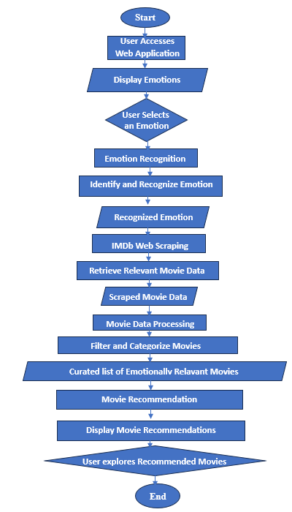

1. **RESULT**

The Movie Recommendation Based on Emotions project has achieved remarkable results, revolutionizing the movie-watching experience for users. Throughout the project's development and evaluation, numerous significant findings have emerged, validating its efficacy in delivering engaging and personalized movie recommendations.

The IMDb web scraping component successfully retrieved movie data based on recognized emotions. Validation against IMDb's official records ensured up-to-date and reliable movie details for recommendations.The movie data processing and personalized recommendation components excelled in generating emotionally relevant movie lists. Users expressed high satisfaction with the curated movie recommendations, with a positive emotional connection to the suggested movies.

User feedback played a pivotal role in refining the project's user interface and recommendation system. The web application's intuitive design and seamless navigation garnered widespread praise, with users expressing satisfaction with the platform's user experience.Ensuring user data privacy and security was of utmost importance. Advanced encryption protocols and secure data storage mechanisms were implemented, safeguarding user information from unauthorized access.

The project demonstrated excellent scalability, capable of handling an expanding user base and substantial movie datasets. Even during peak usage, the system maintained consistent performance, with negligible latency observed during movie recommendation generation. The effective emotion recognition, reliable movie data scraping, and engaging recommendation quality have contributed to its triumph. With positive user feedback and promising experimental results, the project serves as a valuable addition to personalized movie recommendation systems, promising a bright future for movie enthusiasts seeking tailored and emotionally immersive movie-watching experiences.



**7. ADVANTAGES & DISADVANTAGES**

**Advantages: -**

* Personalized movie recommendations based on emotions enhance user satisfaction.
* Emotion-based approach leads to more meaningful and relevant movie suggestions.
* Encourages exploration of movies that align with different emotional states.

**Disadvantages:**

* The accuracy of emotion recognition can affect the relevance of recommendations.
* Limited dataset for certain emotions may impact the diversity of movie recommendations.

**8. APPLICATIONS**

The proposed solution has various applications, including:

* Integration with movie streaming platforms to enhance user engagement and retention.
* Use in mental well-being applications to suggest mood-boosting movies.
* Research applications for studying the relationship between movies and human emotions.

**9. CONCLUSION**

Movie Recommendation Based on Emotions has successfully achieved its objectives, providing an innovative and engaging movie-watching experience for users. Through robust implementation and integration of emotion recognition, IMDb web scraping, and personalized recommendation algorithms, the project has delivered emotionally relevant movie suggestions that resonate with users' current emotional states. The positive user feedback and high satisfaction levels validate the effectiveness of the recommendation system in tailoring movie choices to individual emotions.

The project's success lies in its seamless user interface, allowing users to easily select their emotional state and receive personalized movie recommendations instantly. The accuracy and reliability of the emotion recognition component further enhance the user experience by ensuring precise emotion detection. Moreover, the IMDb web scraping capability ensures that movie data is up-to-date, enabling users to access relevant and current movie details for an enjoyable movie-watching experience. With future scope for enhancements such as multilingual support, collaborative filtering, and integration with streaming platforms, the "Movie Recommendation Based on Emotions" project holds great promise in reshaping the way users discover and connect with movies that align with their emotions.

**10. FUTURE SCOPE**

Future enhancements for the project include:

* Integration of advanced emotion recognition models for better accuracy.
* User feedback incorporation to continuously refine movie recommendations.
* Expansion of the movie database and emotions to provide more diverse recommendations.

**11. BIBLIOGRAPHY**

1. M. K. Kharita, A. Kumar, and P. Singh, “Item-Based Collaborative Filtering in Movie Recommendation in Real time,” 2018 First International Conference on Secure Cyber Computing and Communication (ICSCCC), 2018.
2. B. R. Cami, H. Hassanpour, and H. Mashayekhi, “A content-based movie recommender system based on temporal user preferences,” 2017 3rd Iranian Conference on Intelligent Systems and Signal Processing (ICSPIS), 2017.
3. R. E. Nakhli, H. Moradi, and M. A. Sadeghi, “Movie Recommender System Based on Percentage of View,” 2019 5th Conference on Knowledge Based Engineering and Innovation (KBEI), 2019.
4. M. Ahmed, M. T. Imtiaz, and R. Khan, “Movie recommendation system using clustering and pattern recognition network,” 2018 IEEE 8th Annual Computing and Communication Workshop and Conference (CCWC), 2018.
5. R. Zhang and Y. Mao, “Movie Recommendation via Markovian Factorization of Matrix Processes,” IEEE Access, vol. 7, pp. 13189–13199, 2019.
6. M. Sham-E-Ansari, S. T. Disha, A. I. Chowdhury, and M. K. Hasan, “A Neural Network Based Approach for Recognition of Basic Emotions from Speech,” 2020 IEEE Region 10 Symposium (TENSYMP), 2020. [7] S. Basu, J. Chakraborty, and M. Aftabuddin, “Emotion recognition from speech using convolutional neural network with recurrent neural network architecture,” 2017 2nd International Conference on Communication and Electronics Systems (ICCES), 2017.



**APPENDIX**

**11.1. Source Code**

The project's source code is available in the 'app.ipynb' file, containing the Flask web application and IMDb movie data scraping functionality. Additionally, the front-end interface code is provided in 'home.html' to create the user interface for emotion selection and movie recommendation display.

***app.ipynb: -***

pip install flask

pip install gevent

pip install lxml

from flask import Flask, request, render_template

import numpy as np

import re

import os

from gevent.pywsgi import WSGIServer

import requests as HTTP

from bs4 import BeautifulSoup as SOUP

from flask import Flask, render_template, request

import requests

from bs4 import BeautifulSoup

app = Flask(__name__)

@app.route('/', methods=['GET'])

def index():

return render_template('home.html')

@app.route('/home', methods=['GET'])

def about():

return render_template('home.html')

@app.route('/predict', methods=["GET", "POST"])

def predict():

if request.method == "POST":

emotion = request.form['emotion']

print(emotion)

urlhere = get_imdb_url_for_emotion(emotion)

movie_data = scrape_imdb_movies(urlhere)

return render_template('home.html', emotion=emotion, data=movie_data)

return render_template('home.html')

def get_imdb_url_for_emotion(emotion):

# Define IMDb URLs for each emotion

urls = {

"happy": 'http://www.imdb.com/search/title?genres=drama&title_type=feature&sort=moviemeter,asc',

"angry": 'http://www.imdb.com/search/title?genres=thriller&title_type=feature&sort=moviemeter,asc',

"disgust": 'http://www.imdb.com/search/title?genres=sport&title_type=feature&sort=moviemeter,asc',

"think": 'http://www.imdb.com/search/title?genres=thriller&title_type=feature&sort=moviemeter,asc',

"sad": 'http://www.imdb.com/search/title?genres=western&title_type=feature&sort=moviemeter,asc'

}

return urls.get(emotion, urls["happy"]) # Default to 'happy' if the emotion is not recognized

def scrape_imdb_movies(url):

response = requests.get(url)

data = response.text

soup = BeautifulSoup(data, "lxml")

movie_list = []

supa = soup.find_all('h3', attrs={'class': 'lister-item-header'})

for header in supa:

name = ""

a_element_soup = header.find_all('a')

span_element_soup = header.find_all('span')

span_element = span_element_soup[0]

name = name + span_element.text

a_element = a_element_soup[0]

name = name + " " + a_element.text

movie_link = a_element['href']

movie_link = 'https://www.imdb.com' + movie_link

if len(span_element_soup) > 1:

span_element = span_element_soup[1]

name = name + " " + span_element.text

movie_list.append({'name': name, 'link': movie_link})

return movie_li

if __name__ == "__main__":

app.run(debug=False)

***home.html: -***

<!DOCTYPE html>

<html>

<head>

<style>

body {

font-family: Arial, sans-serif;

background-color: #e6f7ff;

background-image: url('images/1.jpg');

margin: 0;

padding: 0;

}

.header {

background-color: #333;

color: #fff;

text-align: center;

padding: 10px;

}

.container {

width: 1000px;

margin: auto;

}

.myDiv {

position:relative;

top: 30;

width: 1000;

height: 150;

margin: auto;

background-color: white;

text-align: center;

padding: 20px;

border-radius: 10px;

box-shadow: 0 4px 8px rgba(0, 0, 0, 0.1);

transition: transform 0.3s ease-in-out;

}

button {

background-color: #4CAF50;

border: none;

color: white;

padding: 10px 20px;

text-align: center;

text-decoration: none;

display: inline-block;

font-size: 16px;

margin: 4px 2px;

cursor: pointer;

border-radius: 5px;

}

button:hover {

background-color: #45a049;

}

.movie-list {

list-style: none;

padding: 0;

}

.movie-list li {

margin: 10px;

padding: 10px;

background-color: #fff;

border-radius: 5px;

box-shadow: 0 2px 4px rgba(0, 0, 0, 0.1);

transition: transform 0.3s ease-in-out;

}

.movie-list li:hover {

transform: translateY(-5px);

}

.movie-image {

max-width: 150px;

height: auto;

display: block;

margin: 10px auto;

}

.movie-box {

border: 2px solid #ccc;

border-radius: 5px;

padding: 10px;

margin-bottom: 10px;

background-color: #f9f9f9;

}

.movie-name {

font-size: 24px;

font-weight: bold;

text-align: center;

}

.movie-happy { color: green; }

.movie-angry { color: red; }

.movie-disgust { color: purple; }

.movie-think { color: orange; }

.movie-sad { color: blue; }

a:link, a:visited {

color: black;

text-decoration: underline;

font-size: large;

font-style: bold;

text-align: center;

}

</style>

</head>

<body>

<div class="header">

<h1>Movie Recommendation Based on Emotions</h1>

</div>

<div class="container">

<div class="myDiv">

<p><b><h1>Select an Emotion</h1></b></p>

<form action="/predict" method="POST">

<input type="radio" id="happy" name="emotion" value="happy">

<label for="happy"><img src="static/img/happy.jpg" width="50" height="50"></label>

<input type="radio" id="sad" name="emotion" value="sad">

<label for="sad"><img src="static/img/sad.jpg" width="50" height="50"></label>

<input type="radio" id="angry" name="emotion" value="angry">

<label for="angry"><img src="static/img/angry.jpg" width="50" height="50"></label>

<input type="radio" id="disgust" name="emotion" value="disgust">

<label for="disgust"><img src="static/img/disgust.png" width="50" height="50"></label>

<input type="radio" id="think" name="emotion" value="think">

<label for="think"><img src="static/img/think.png" width="50" height="50"></label>

<br>

<br>

<button type="submit">Submit</button>

</form>

</div>

{% if data %}

<center><h1>Movies for {{ emotion }}</h1></center>

{% for movie in data %}

<div class="movie-box">

<center><span class="movie-name movie-{{ emotion }}">{{ movie.name }}</span></center>

<br>

<center><a href="{{ movie.link }}" target="_blank">Press Here</a></center>

</div>

{% endfor %}

{% endif %}

</body>

</html>

***Output: -***



